Purpose of the game:

Level Design Considerations
General Considerations: Don’t introduce too much to the player at once – at most, introduce two major mechanics in the same level. There should be something that the player can immediately focus on, and I need to guide the player to it.
Level 1: We don’t want to introduce much here. Note that players will typically read left-to-right, top-to-bottom. So, we need to give instructions in that order. There are some exceptions to this rule, such as when text is closely grouped. The ‘move’ and ‘carry’ instructions are grouped vertically for this reason.
Players will likely start looking at the screen on the top-left, so that is where the first instructions will go. Their eyes will likely follow to the closest object after reading the first, which is the carry direction. Next, the player and the dog. At this point, they will likely either begin moving the player around to get a feel for the movement or immediately go to the dog. Wandering players will still likely be close to the dog, so they can try out the carry button.
With the dog in hand, the only thing left in the level is the door and the instructions to enter the door. Most players will already be carrying the dog at this point, so the reminder to not forget the dog will be redundant. However, it reinforces this rule to the player early on while also guiding players that didn’t immediately pick up the dog to go and do so.
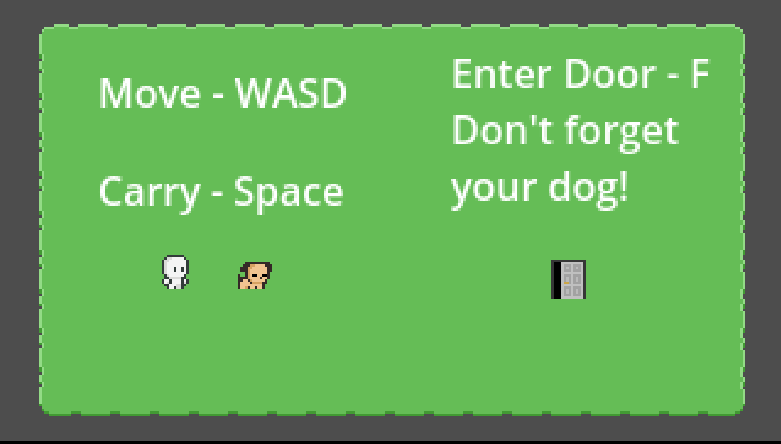
Level 2: There are two major mechanics to introduce now: pushing and time-shifting. However, doing both at once may be too complicated for this early in the game, especially given the complexity of the latter. So, Level 2 is built around the pushing mechanic. The new elements here are buttons and boxes – when the button is held down by any object on top of it (including boxes), the door will open, allowing the level to be completed. In this level, the player is expected to push the box onto the button. As the box is immediately to the right of the button and the player is to the right of the box, the player simply has to push the box once to open the door. From this point, the player just has to pick up the dog and interact with the door. The dog is placed in front of the door to remind the player that they must be carrying the dog to finish the level.
